**Students Name:**

**Student ID:**

**Section Number:**

**Company:** Nike

**Company Supply Chain**

Nike, being the largest retailer of sportswear, footwear and sports equipment in the world has had to develop a very strong supply chain (Sabanoglu, 2021). In addition to the large number of customers, Nike has partnered with multiple high-profile athletes and sporting companies and therefore Nike has to be very keen on timely and quality product delivery. Nike has outsourced all its production processes in order to focus on design, customer relations, marketing and expansion plans. Nike has therefore contracted several factories globally that do the work of manufacturing.

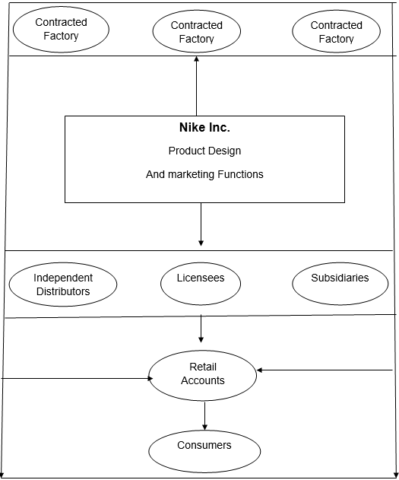

Figure 1: Summary of Nike's Supply and Distribution Chain

On the area of raw materials and product manufacturing, Nike completely relies on external suppliers and does not do anything in-house. Nike has create a wide base of competent suppliers through a rigorous vetting process. The one thing that Nike is keen to check is quality of the raw materials and quality of the manufactured products. Nike has a global team that is in charge of the procurement process at Nike and also vets suppliers to ensure that they contract capable companies that will deliver the required quality, in the required amounts and on time. By the end of 2019 independent contract manufacturers contracted by Nike and located in 12 countries were responsible for the manufacture of all of Nikes products. (Enderle, 2000)

One strategy that Nike uses when contracting manufacturers is the emphasis on quality and also long term engagement with these contractors. The emphasis on Quality is to retain customer satisfaction and keep building the brand name. Nike also insists on long term arrangement with contractors because once you have worked with someone for long, you get too understand them more and will rarely have any issues especially on quality and communication

For all the contractors, Nike has established a code of conduct and Code Leadership standards. The code of conduct lays out the minimum requirements for all of its suppliers' factories and facilities. It establishes a number of requirements, the most important of which are related to forced labor, child labor, excessive overtime, and compensation. Nike conducts regular audits of its suppliers' factories to ensure that they remain compliant (Supplier Code of Standards)

On the distribution part, Nike has built a very strong and efficient distribution system that ensure that products reach the customer very fast. Nike has distribution and logistic center that serve Nike Retail stores, online shoppers and individual other retailers of Nike roducts.These centers shorten the path betwwen the customer and the production line.The stores make sure that they have enough products depending on changing demand of the products.The largest distribution center is in Memmphis,Tenesse which server the more than 2000 Nike stores in North America (Nike Opens Its Largest Distribution Center Worldwide In Tennessee, 2015). The logistics center offers higher cost efficiency by reducing shipping time and increasing service capabilities. Other such center are in Belgium. These regional logistics campuses or distribution centers have helped Nike manage a faster and smarter supply and distribution chain.

With development in technology, Nike has adopted technology into the supply chain and uses technology to monitor performance and predict demand and supply patterns which are used to inform production and distribution decisions by the management. Keeping customer information including delivery locations also helps the managers make decision on which areas need more effort in terms of distribution.Nike has also developed an ecommerce platform that customers can shop for merchandise and get home deliveries with their preferred shipping methods such as DHL. For customers who prefer picking products from the physical stores, Nike also allows them to pick up products. Nike gives its premium members added advantages depending on subscription level including free shipping (What are Nike's Shipping Options?)

# References

Enderle, K. (2000, March 14). *Strategic Analysis of Nike, Inc.* Retrieved from Condor: https://condor.depaul.edu/~aalmaney/StrategicAnalysisofNike.htm

*Nike Opens Its Largest Distribution Center Worldwide In Tennessee.* (2015, June 26). Retrieved from Nike News: https://news.nike.com/news/nike-opens-its-largest-distribution-center-worldwide-in-tennessee

Sabanoglu, T. (2021, February 19). *Nike - Statistics & Facts.* Retrieved from Statita: https://www.statista.com/topics/1243/nike

*Supplier Code of Standards.* (n.d.). Retrieved from Nike: https://purpose.nike.com/code-of-conduct

*What are Nike's Shipping Options?* (n.d.). Retrieved from Nike: https://www.nike.com/help/a/shipping-delivery